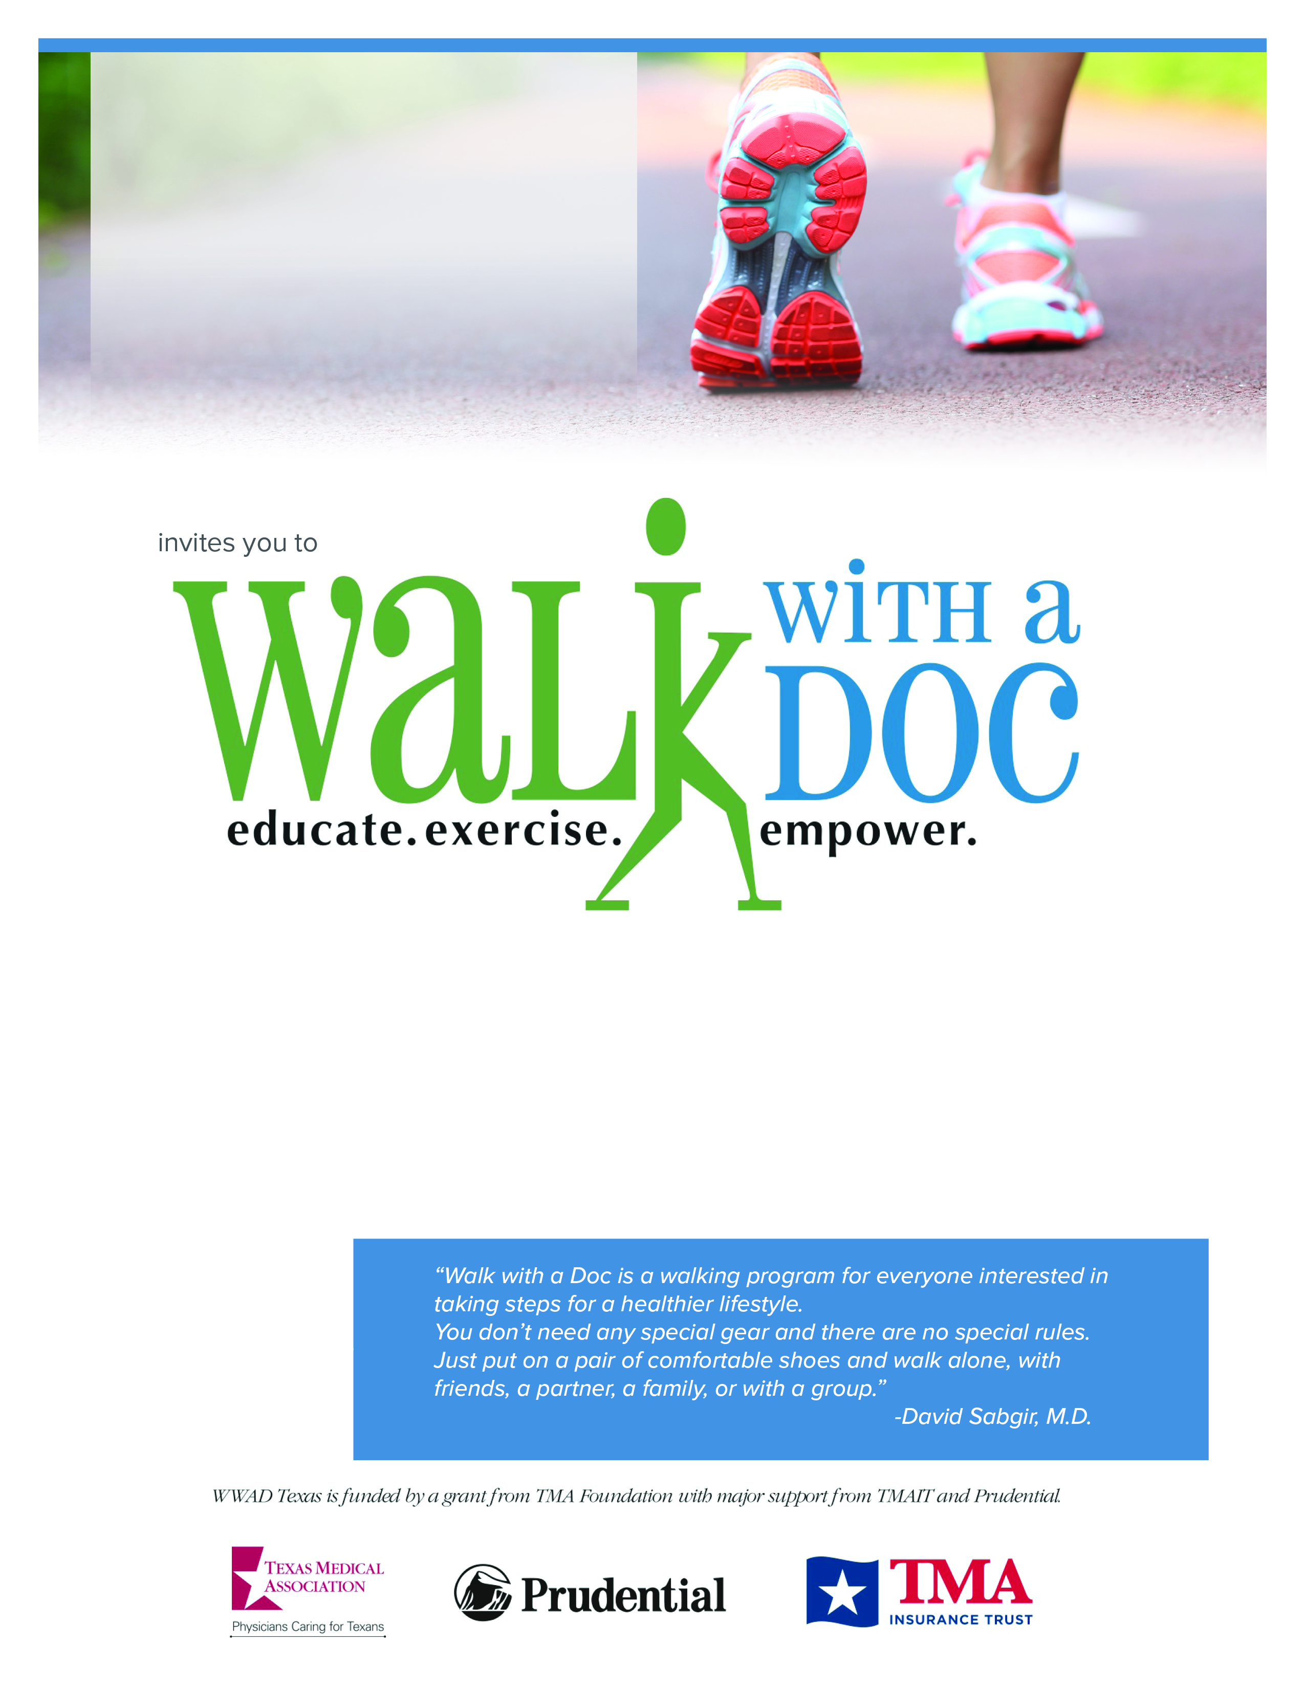

**Sat. September 11, 2021**

**4:00 – 5:00 PM**

**Cushwa Basin C&O Canal**

**(205 Potomac St, Williamsport, MD)**



Willow Brook SDA Church

**Questions?**

Email Address: WBHealthMin@gmail.com

**Have fun and join us for Walk with a Doc.**

You’ll take a few minutes to learn about a current health topic, then spend the rest of the hour enjoying a healthy walk at your own pace and distance. It’s a great way to get some exercise, learn about health, and meet new friends. The event is **free** and open to everyone, so please feel free to bring family or friends!

We are a local chapter of an international program. Learn more at **www.walkwithadoc.org**