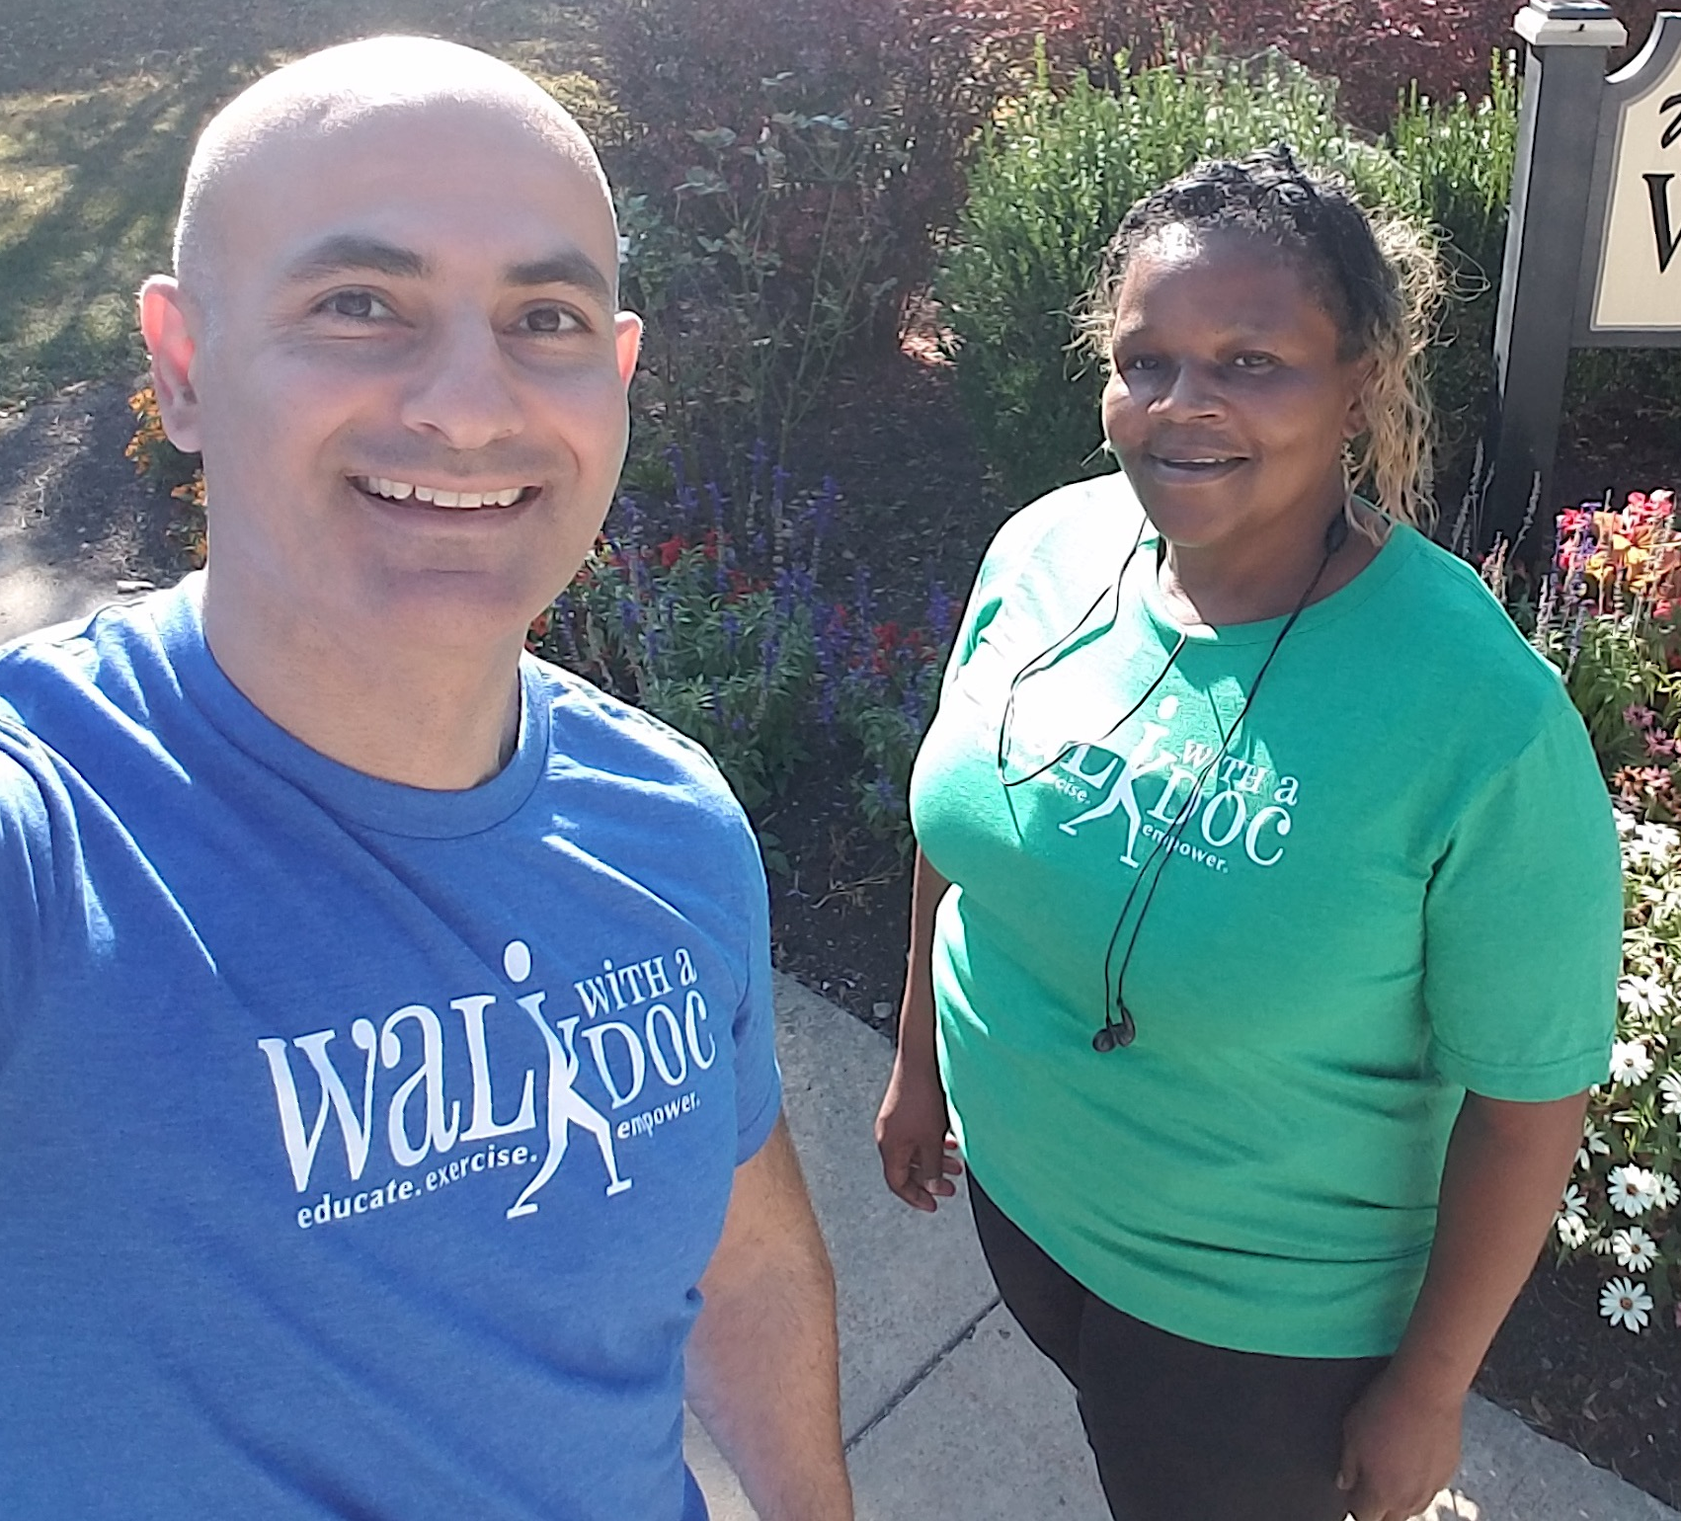
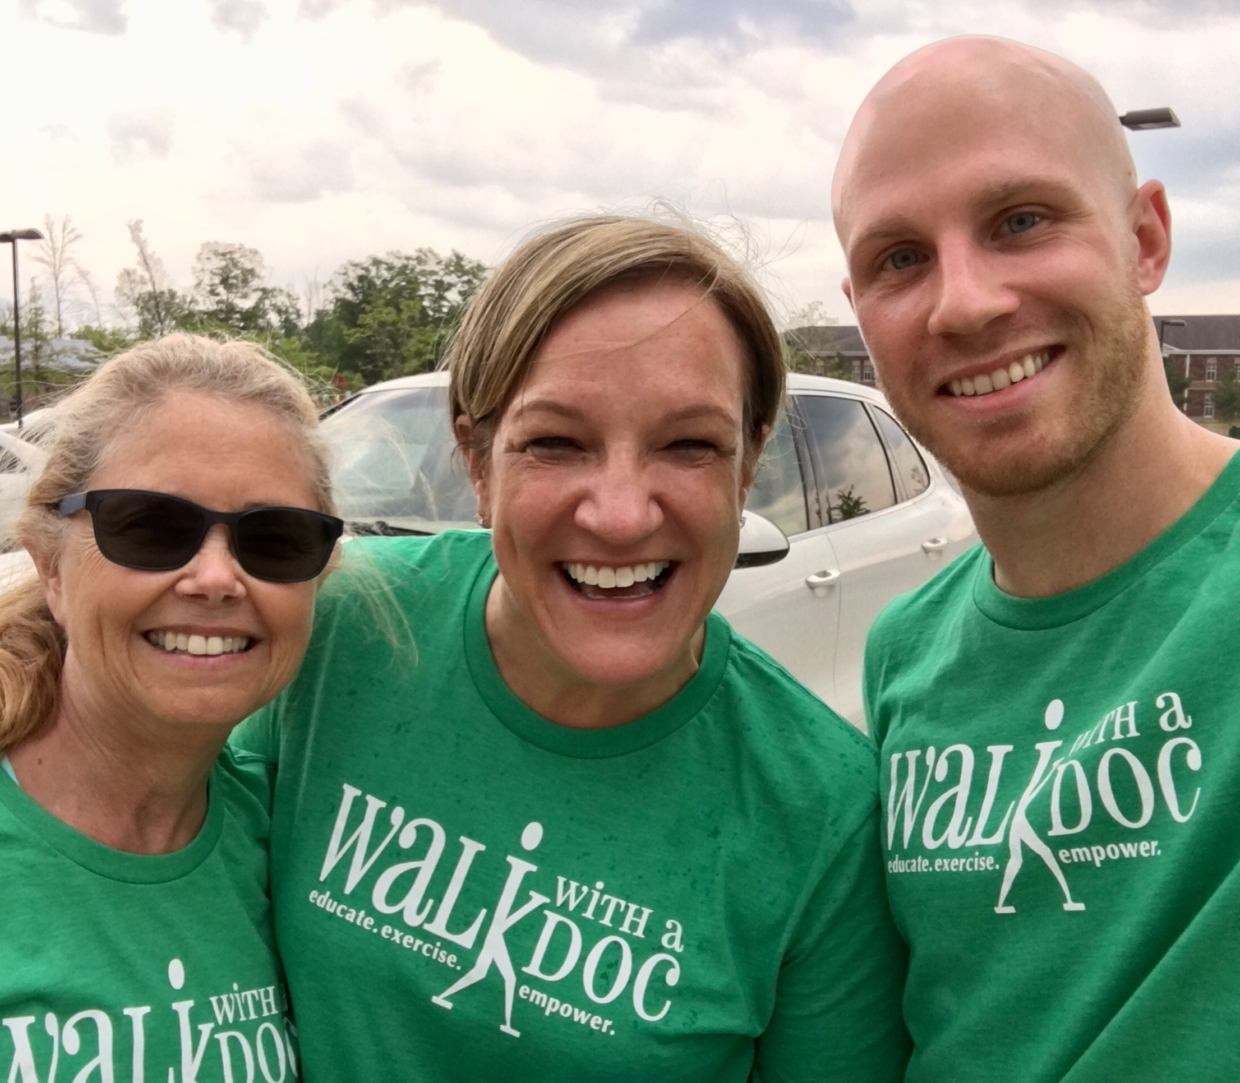
JOIN DR. RAO FOR A WALK

WHO: DR. RAO

WHAT: A FREE 60 MINUTE WALK WITH THE DOC.
WALK YOUR OWN PACE AND DISTANCE

WHEN: SAT. SEPTEMBER 11, 2021 @ 4:00 PM

WHERE: CUSHWA BASIN 205 POTOMAC ST, WILLIAMSPORT, MD

WHY: DID YOU KNOW JUST 30 MINUTES
OF WALKING A DAY CAN:

- Increase your energy

- Help you sleep better

- Increase productivity

- Make you feel happier within just 10 minutes

See 96 more reasons at www.walkwithadoc.org/why-walk/

